**Photosynthesis and Respiration Equations**

Analyze the Diagram below and answer the analysis questions.

[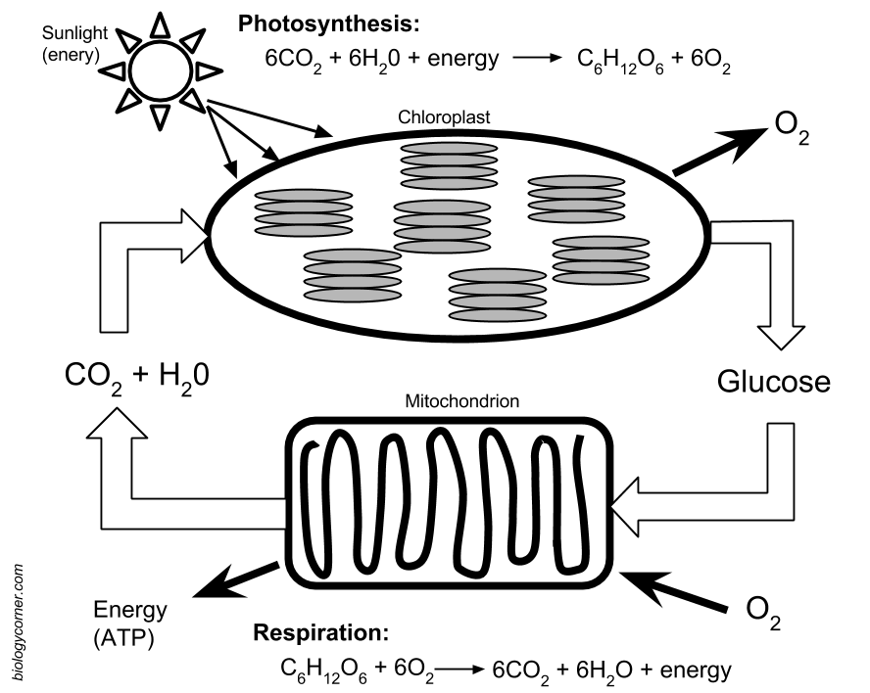](https://www.google.com/url?sa=i&rct=j&q=&esrc=s&source=images&cd=&cad=rja&uact=8&ved=0ahUKEwjE3_O1u6TTAhXGJCYKHfXQBz0QjRwIBw&url=https://www.pinterest.com/oliviazbird/photosynthesis-respiration/&psig=AFQjCNFrzrc2e17CJloysjCzuwiqn2gM2w&ust=1492277063947256)

1. What is the chemical equation for photosynthesis?

__________________________________________________________

1. What is the chemical equation for cellular respiration?

__________________________________________________________

Fill in the table below.

|  |  |  |
| --- | --- | --- |
|  | Photosynthesis | Cellular Respiration |
| Reactants |  |  |
| Products |  |  |
| Organelle |  |  |

